The Homeowners Association of Cypress Lakes
Architectural
Review Board Guidelines

Approved by CLHOA Board of Directors on February 19, 2018.

Table of Contents

1.0 Architectural Review Board (ARB) Submissions
2.0 Exterior House Colors – (Must receive prior ARB approval.)
3.0 Set Backs
4.0 Sheds – (Must receive prior ARB approval.)
5.0 Fences – (Must receive prior ARB approval.)
6.0 Pools and Pool Screen Enclosures – (Must receive prior ARB approval.)
7.0 Screen Enclosures – (Must receive prior ARB approval.)
8.0 Room Additions/Sun Rooms – (Must receive prior ARB approval.)
9.0 Satellite Dishes – (Must receive prior ARB approval.)
10.0 Recreational Structures and Equipment – (Must receive prior ARB approval.)
11.0 Garbage Cans & Recycle Bins
12.0 Gas Tanks and Air Conditioners – (Must receive prior ARB approval.)
13.0 Rubber Mulch
14.0 American Flag Poles – (Must receive prior ARB approval.)
15.0 Fountains – (Must receive prior ARB approval.)
16.0 Landscape Changes/Additions
17.0 Real Estate Signs
18.0 Variances
1.0 Architectural Review Board (ARB) Submissions
1.1 All submissions to the ARB should include two complete sets of construction plans, surveys; site plans or other documents as noted herein. One set will be retained in the files and the other will be returned to the applicant or contractor (whichever is appropriate).
1.2 Please provide appropriate contact information with your submission in the event the ARB needs to contact you in regards to your submittal package.

2.0 Exterior House Colors – (Must receive prior ARB approval.)
2.1 A suggested color palette will be provided by the ARB.
Ref: Covenants VII A, B(2), page 16
2.2 Exceptions must be approved by the ARB and the Board of Directors.
2.3 Any house painted with nonconforming colors before January 2018 can remain until repainted.
3.0 Set Backs
3.1 The property shall be subject to the building setback restrictions depicted on the site survey.
3.2 No vertical construction will be allowed within the building set back restrictions.

4.0 Sheds – (Must receive prior ARB approval.)
4.1 Any necessary permits must be obtained from the county prior to submission to ARB with the understanding the applicant might have to go back to the county if the ARB requests any changes.
4.2 Location of shed must be noted on plot sheet/site survey with ARB submission. Location of shed must meet county setbacks of 25-ft. from front, 5-ft. from side, and 15-ft. from the back.
4.3 Shed shall not exceed 8-ft.x 10-ft.x 9-ft. high. Only plots with an acre or more are eligible.
4.4 A minimum of 5-ft. high, 4-ft. apart landscape must be used to minimize the visibility of the shed from the street and golf course. Landscape plan must be submitted with the shed submission. Landscape must be installed at time of shed installation.
4.5 Shed must be same as house body color and roof must be the same color and material as the house roof.
4.6 Variances may be given for corner lots.

5.0 Fences – (Must receive prior ARB approval.)
a. A copy of your survey indicating the location of the fence must be included with your application in order to receive approval.
b. Common Information:
1. Open black metal fences can be used on any lot
2. Chain link fencing is never allowed.
3. No two (2) fences shall be installed side by side along a common property line.
4. A homeowner wishing to install a fence after his neighbor’s fence has been installed must join to the existing fence. Homeowner must have a waiver or agreement in writing from neighbor before attaching to their fence. Otherwise a post next to a post is acceptable.
5. On corner lots, fences must be setback a minimum of five (5’) feet to twenty (20”) feet off the property line along the side street.
6. If the circumstance should arise that the rear yard of a corner lot aligns with the front elevation of a home on an adjacent lot, the fencing along the side of the corner lot must align with the front elevation of the home on the adjacent lot. The ARB, depending on the location of the adjacent homes, will determine the exact fence location.
7. Fencing encroaching on any drainage easements must not impede the flow of water thru the easement
8. FENCES CANNOT GO INTO LAKE OR STORMWATER MANAGEMENT AREAS OR OTHER DESIGNATED EASEMENTS.
9. Fences near some drainage easements may be permitted with the understanding that SHOULD IT BE NECESSARY TO ACCESS THE EASEMENT, HOMEOWNER IS RESPONSIBLE FOR REMOVING THE FENCE and any other obstructions or landscaping AT THEIR EXPENSE.

5.1 Fence Types There are only two (2) types of fencing materials acceptable for the neighborhood. The type of fencing is driven by the lot type. There are three (3) applications listed below:
a. View Lots: Four-foot, “open” style fences, such as aluminum or wrought iron in bronze (black) are the only standard accepted fences allowed on view lots such as golf course or lake lots.
b. Preserve Lots: Some lots that border the drainage/access easement on Cypress Links Blvd. may have a six-foot wood shadowbox or board-on-board fence.
5.2 View Lots
a. All fences should be four-foot black aluminum fences.
b. Fences cannot come further forward along the side property line than one quarter of the distance from the back corner of the house.
c. These metal fences can be installed on the property lines.
5.3 Preserve Lots
a. If a six-foot wood shadowbox or board-on-board fence is approved; it cannot be painted but maybe stained and sealed.
b. Plastic fences are not approved.
c. The fence must come off rear corners of house straight back to the rear lot line or easement.
d. Fence cannot be placed on the side property lines.
e. All structural supports are to be on the inside of the fence facing the lot’s interior.
5.4 Fence Screens – To hide A/C units, gas tanks and trash bins.
a. Wooden fencing (shadowbox or board-on-board) may be used.
b. They must have a height limit of four-foot and are not to extend further than eight- feet from the house and must meet setback requirements.
c. They must be painted the same color as the main body of the home.
5.5 Architectural approval from the association is a limited approval. The owner is responsible for compliance with any governmental agency requirements.

6.0 Pools and Pool Screen Enclosures – (Must receive prior ARB approval.)
6.1 All pools and pool screens require approval prior to construction. A bronze screen frame is required and there will be no flat or shed type roofs allowed. The roof pitch of the enclosure should match or be in keeping with the roof pitch of the house. All pools and screens shall be located at the rear of the property and meet all setback requirements for the community. The width of the pool and screen cannot exceed the width of the home. Pool equipment must be buffered with mature landscaping to hide the equipment.
6.2 When digging and pumping for the pool, the hose needs to be kept on the lot so that the lot absorbs the silt and water. All backwashing of the pool needs to be onto the lot and not into lakes, storm sewers or streets.
6.3 Your submittal should include a survey with pool, screen, and equipment located on it, elevation drawings of the screen enclosure showing all measurements, including height, with colors noted on the plans for your enclosure.
6.4 Architectural approval is a limited approval. The owner is responsible for seeing that the pool and enclosure are in complete compliance with all governing agencies including but not limited to safety building code regulations.

7.0 Screen Enclosures – (Must receive prior ARB approval.)
7.1 All screen enclosures require approval prior to construction. A bronze frame is required and there will be no flat roofs allowed. The roof pitch of the enclosure should match or be in keeping with the roof pitch of the house. White is acceptable only if the trim of the house is white.
7.2 Your submittal should include a survey showing the footprint of the screen enclosure and elevation drawings showing all measurements, including height.
7.3 Screen enclosures will be approved on an individual basis. The approval is for architectural purposes and is a limited approval. The owner is responsible for compliance with all governing agency requirements.

8.0 Room Additions/Sun Rooms – (Must receive prior ARB approval.)
8.1 Room additions require a complete submittal that should include architectural plans, a survey indicating the addition is in compliance with the community setback requirements, and samples of exterior colors. All materials, colors, shingles, windows, applications, etc. are to match the existing home. The pitch of the roof of the new structure must match the existing roofline. Pan or flat roofs are not allowed.
8.2 Architectural approval from the association is a limited approval. Any addition must meet the standards of all governing agency requirements.
8.3 The Review Fee for a Room Addition may be $200.00, if necessary.

9.0 Satellite Dishes – (Must receive prior ARB approval.)
9.1 Subject to federal guidelines, all antennae, satellite dishes and other receptor devices to be installed on the Property shall be no larger than thirty-nine inches (39”) in diameter and twelve (12’) feet in height. Such devices shall not be placed in the front yard of any Lot. In addition, Owners shall endeavor to assure that the locations of such devices are screened to the extent possible from the view of others. (taken from page 20 (i) of covenants).

10.0 Recreational Structures and Equipment – (Must receive prior ARB approval.) All requests must include a lot survey with the proposed location drawn on it.
10.1 Play equipment must be made from wood or plastic rubberized coating over metal, and be located in the rear yard.
10.2 Must place desired location on site survey with ARB submission.
10.3 Plants are unnecessary, but recommended to help hide view from street.
10.4 In addition, a picture or brochure needs to be included to show design, size, and color. Accent colors for slides, swing seats, canopies, etc., are to be Hunter Green, Navy Blue, or yellow only.
Trampolines
10.5 Trampolines will be allowed.
10.6 Please Note: The Association will not be liable with respect to its approvals in case of personal injury or property damage.
10.7 Must be located directly behind home, not visible from street to include seeing the safety netting of the trampoline. Variances may be given for corner lots.
Basketball Backboards
10.8 No permanent goals allowed.
10.9 Portable backboard cannot be aimed at the street or placed on street curb.
10.10 The pole must be black or dark brown and the backboard must be clear or white.
10.11 During hurricanes (warning), rims/goals need to be placed on their side in the backyard of the property.
10.12 Must be in working order and in good condition.
Volleyball Nets
10.13 A minimum of 5-ft. high, 4-ft. apart landscape must be used to minimize the visibility of the volleyball nets from the street and golf course. Landscape plan must be submitted with the volleyball net submission. Landscape must be installed at time of volleyball net installation.

11.0 Garbage Cans & Recycle Bins
11.1 Cans & bins must be either inside the garage or may be on the side of the house. If on the side of house, they must be shielded from view of neighbors and the street with plantings or fencing. Do not put garbage or recycling out before 6PM on the day before scheduled pickup.
11.2 Wooden fencing must not exceed four (4) feet and painted the same as house body color.
12.0 Gas Tanks and Air Conditioners – (Must receive prior ARB approval.)
12.1 A site survey needs to be submitted, showing the location and how it will be landscaped to buffer it from neighbors and the street.

13.0 Rubber Mulch
13.1 Rubber Stuff Mulch has been approved as a substitute for regular mulch in plant beds. The approved colors are Cypress Brown, Pine Bark, or Rustic Red. No review is necessary.

14.0 American Flag Poles – (Must receive prior ARB approval.)
14.1 The minimum height for a flagpole is to be 2/3 of the height of the peak (crown) of the roof of the home.
14.2 The maximum height for a flagpole is no higher than the peak (crown) of the roof of the home.
14.3 The size of the flag is to be in scale with the height of the pole.
14.4 Poles are to be either clear anodized aluminum or white.
14.5 If the flag is left out overnight, it is to be lit with a 12-volt light. Lighting is to be directed at the pole and is not to impact adjacent homes.
14.6 Flags attached to the home with the proper flag kit do not require approval.
14.7 No more than two flags are to be flown at any one time.

15.0 Fountains – (Must receive prior ARB approval.)
15.1 Fountains will be reviewed on a case-by-case basis depending on existing landscaping, property location, location of fountain in yard, etc. They are to be landscaped with shrubs and/or trees planted to accent and reduce the visual impact of the fountain.
15.2 Fountains and landscaping must be maintained in good condition.
15.3 Fountains must be of an architectural style and color to blend with the design and color of the home. Colors are to be black, white, or natural concrete color only.
15.4 Fountains are to be no higher than 60" to 72", depending on the design and height of the home.
15.5 Fountains cannot be positioned closer than 25 feet from any property line, but the ARC can impose additional set back requirements to ensure proper aesthetics. The ARC may also grant a variance to the 25-foot setback requirement in certain instances.

16.0 Landscape Changes/Additions
16.1 If major landscape changes (changing/adding more than 50% of landscaping in place) are being made, provide two copies of the landscape design plans by a designer or landscape architect – (Must receive prior ARB approval.)

17.0 Real Estate Signs
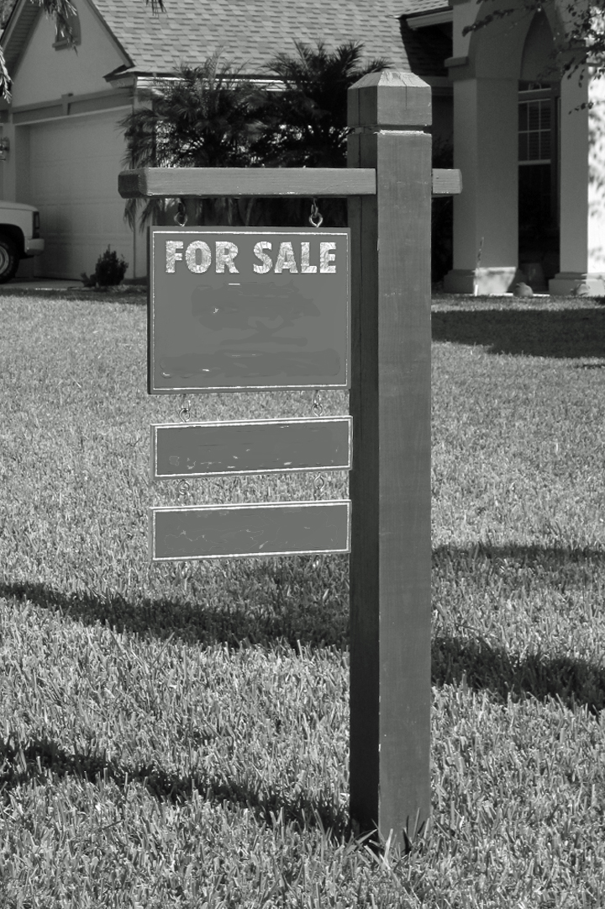
Acceptable Realtor Sign Design for Sale and Rental Situations
17.1 "For Sale" or "For Rent" signs shall all conform to the following guidelines:
a. 4”x4” wooden posts. (See above photo)
b. Sign Panel, 10 1/2" x 13 1/2" d. (A flyer holder may be attached to the post.)
c. Optional: frame extension of 4" x 13 1/2" for sign rider.
18.0 Variances
18.1 The ARB, as applicable, may authorize a variance from compliance with any of the architectural provisions per the Declaration of Covenants when circumstances such as topography, natural obstructions, hardships, or aesthetic or environmental consideration(s) require the same. A variance shall be evidenced by a document signed by the chairman of the ARB if it involves a proposed Improvement. If such a variance is granted, no violation of the covenants, conditions and restrictions contained in the Declaration of Covenants shall be deemed to have occurred with respect to the matter for which the variance was granted. The granting of such a variance shall not, however, operate to waive any of the terms and provisions in the Declaration of Covenants for any purpose except as to the particular Lot and the particular provisions of the Declaration of Covenants covered by the variance, nor shall it affect in any way the Owners' obligation to comply with all governmental laws and regulations, including, but not limited to, zoning ordinances and set back lines or requirements imposed by any governmental or municipal authority. Provided, however, in no event shall granting of a variance set a precedent which required the granting of another such variance.

